First Exercise:

***Skin Detection using MAP classifier***

First part:

* Learning the Probabilities of the skin and background models:

We get a data which consists of the red and green ratios of the pixel (which is our 2x1 feature vector), we then learn the distribution of those features across skins and backgrounds, which is done using what we learned in class about simply averaging the feature vectors each class and calculating the sigma.

The distributions turn out to be : 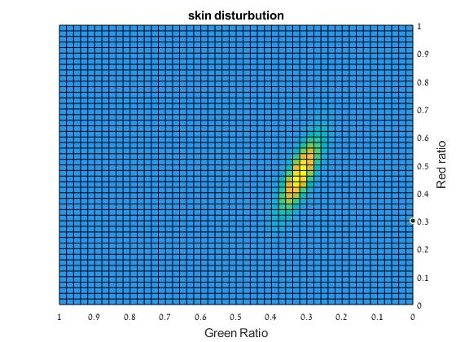

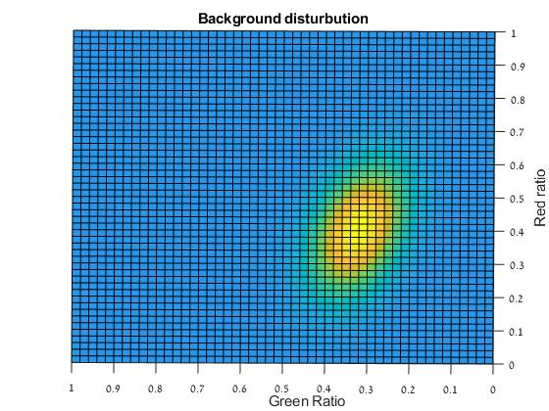

Then we send the likelihood ratios of the validation set to compute the ROC curve and chose the optimal threshold [*******************************ADD*****************************].

* Second Part: Classifying images

in This part we run over the each individual pixel and check the likelihood ratio for it being a skin over the probability of it being a background and If the likelihood ratio turned out to be bigger than the threshold we assume it’s a skin, otherwise it’s a background.

Results:

We ran the classifier on 5 images, results were as follow:

Choosing the trivial Threshold:

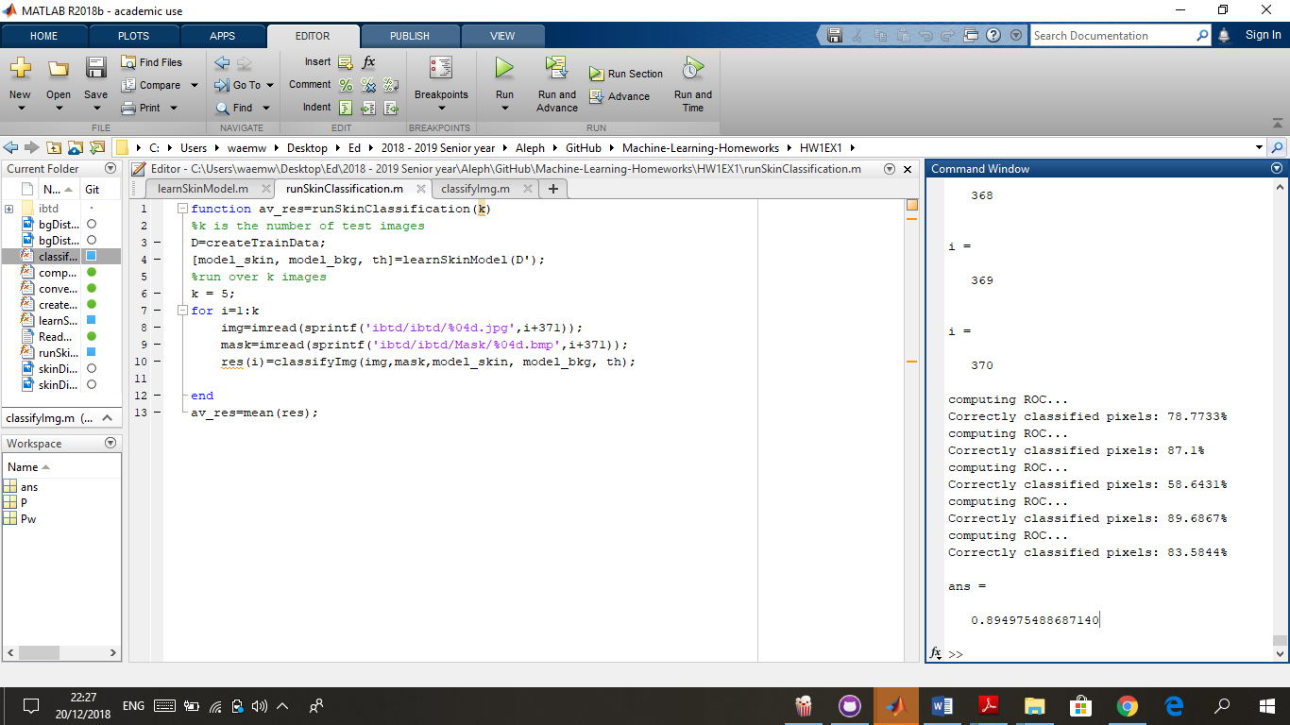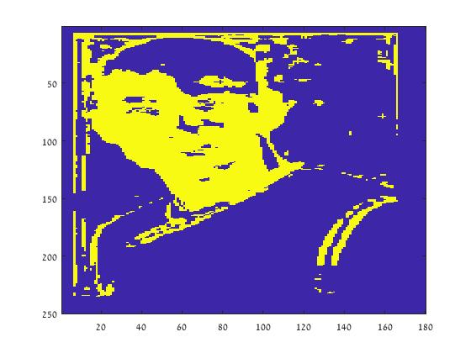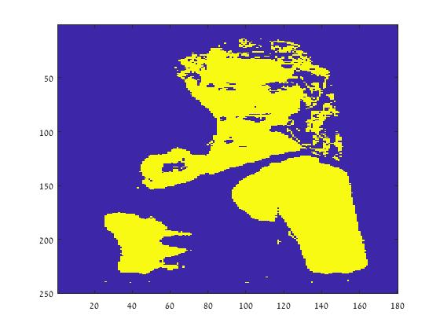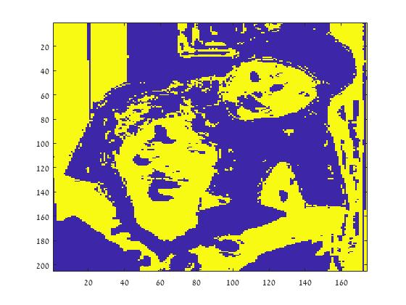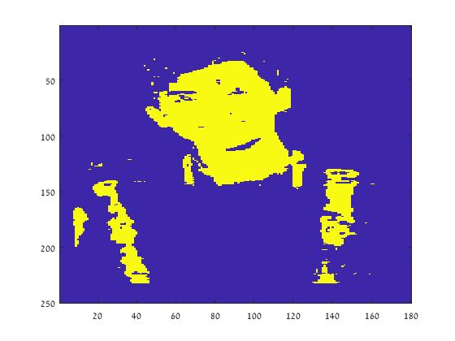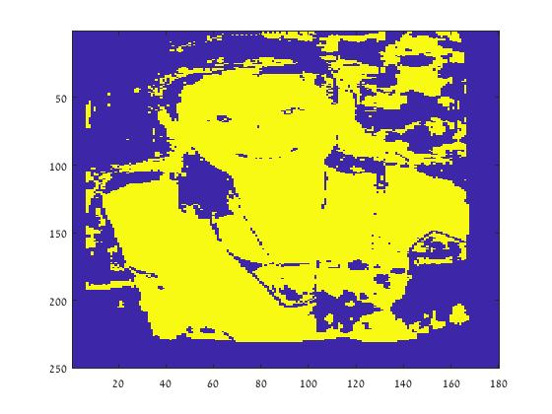

Choosing the threshold that counts for the priors of the classes:

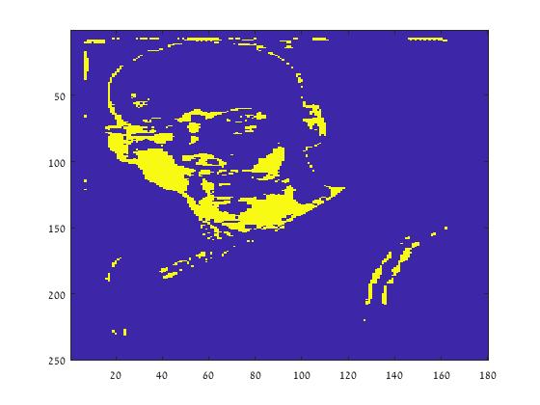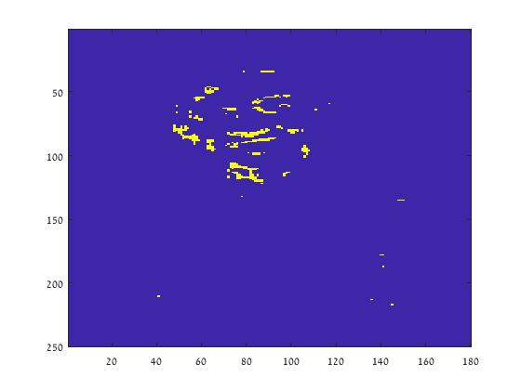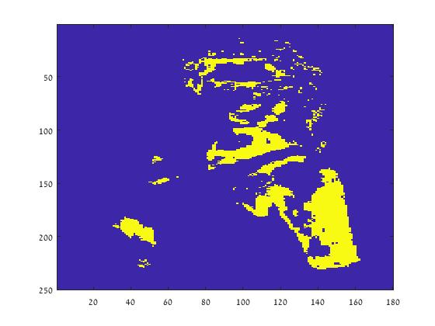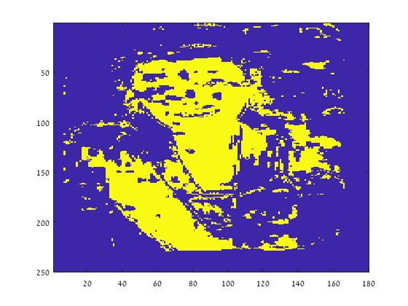

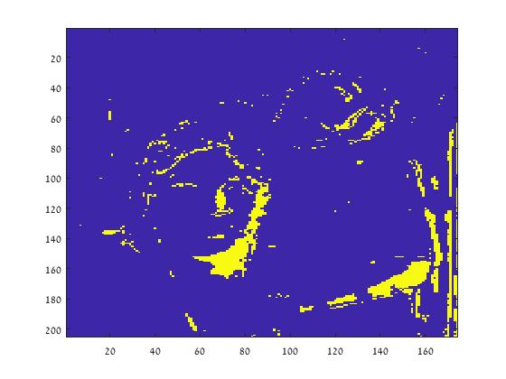

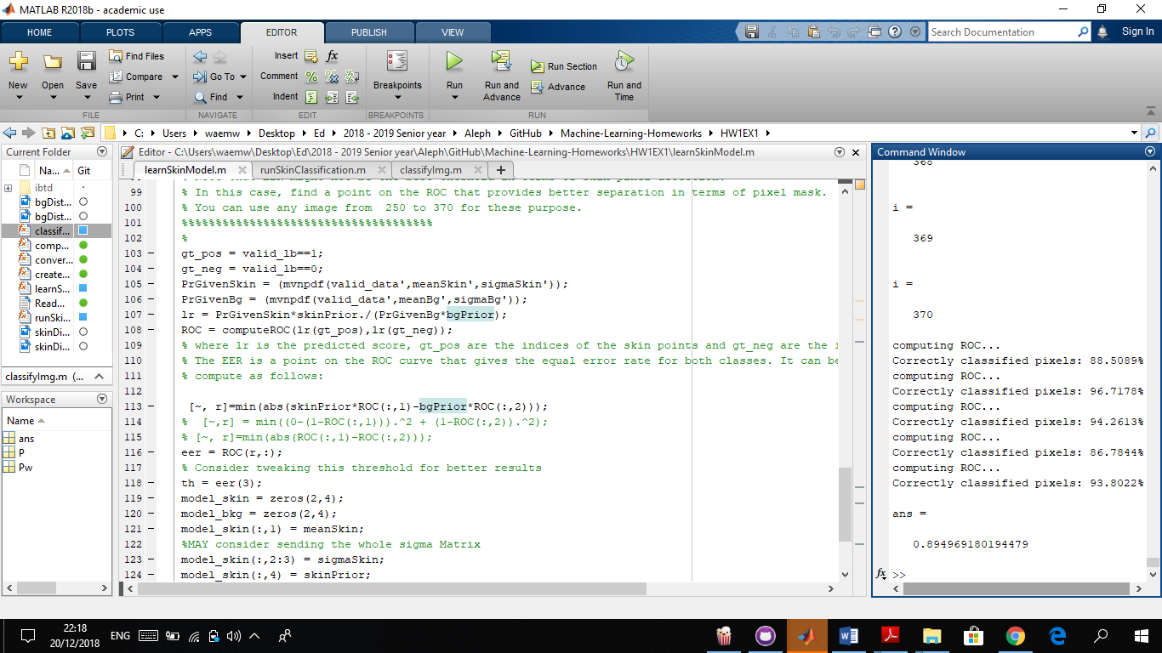

As we can see from the results, choosing the trivial threshold leads to a “better visual” detection of skin, while the other threshold classifies a bigger percentage of pixels correctly but it looks off.

Second Exercise:

**Text Classification Using Naïve Bayes Algorithm**

In the Attached .m Files we can see the implementation of the Naïve Bayes algorithm for learning and classifying the category of given a text, under the assumptions of the “Bag of words Model” that we learned in class (independence between words and their positions in the document).

After learning the probabilities of words and categories using the training text. we ran the classifier on the testing text, and the success rate turned out to be:

***Success Rate: 96.07%***

*Success rate in format long*

*0.960712654179991*

